|  |
| --- |
| University of Strathclyde |
| Distributed Information Systems |
| ontology |
|  |

|  |
| --- |
|  |

Table of Contents

Description of the purpose of the ontology……………………………………………………….2

Description & diagram of the ontology…………………………………………………………...3

RDF/RDFS/OWL…………………………………………………………………………………..

SPARQL queries…………………………………………………………………………………..5

Critique……………………………………………………………………………………………7

Description of the purpose of the ontology

This ontology is a formal description of a part of the business of the University of Strathclyde’s Centre for Sport & Recreation domain. Is a representation vocabulary, specialized to the Sport & Recreation subject. More precisely, it is not the vocabulary as such that qualifies as ontology, but the conceptualizations that the terms in the vocabulary are intended to capture. It conceptualizes elements like objects and relationships. The main classes of this ontology are based on the infrastructure of the sport center, like the human resources, equipment that is used by customers, and the relation between them. It is constituted by a specific vocabulary used to describe a certain reality and a set of explicit assumptions regarding the intended meaning of the vocabulary. Inside the specific domain of interest is try to give answers to questions like what terms and vocabulary are related to a sports centre, like what defines a personal trainer, what kind of subscriptions are available and how are related to customers, employees, and different kind of classes. The ontology is used to analyse the domain of knowledge, separate domain of knowledge from the operational knowledge, and enable reuse of domain of knowledge. The basic terminology of the ontology is CLASS-MODIFIER-DEFINABLE and relation which connect the concepts. So important elements of the specific domains are the infrastructure of the sports centre, like reception and training rooms, or dressing room, the machines that are used, and the people that are related to the sports center. Some background knowledge and constraints are also important, like for example a personal trainer it’s an extra service, which requires gold membership which means more money for customers. Using axioms we can define concepts, like a Personal trainer who is an Employee who trains only customers with Gold subscription. Consequently only customers with gold subscription will have access to personal trainer services. We can use the terms provided by the domain ontology to assert specific propositions about the domain. Some sample questions that can be answered by this ontology are:

* Are female or males the majority of bodybuilder?
* Are female or males the majority of participants in aerobics class.
* What weight do usually bodybuilders have?
* Does a gold subscription include a personal trainer?
* What kind of machinery abs class use?
* Individuals with gold subscription

*Ontology Diagram*

|  |  |  |
| --- | --- | --- |
| Classes | Modifiers | Definables |
| Infrastructure  Training room  Reception  Dressing room  Class  Subscription  Timetable  Machinery  Aerobic machinery  Exercise bike  Run treadmill  Abs Bench  Weight machinery  Bench press  Weight bench  Rubber Barbell  Hex Weight  Person  Bodybuilder  Cross fitter  power lifter  Employee  Customer | Gender  Female  Male  Weight  Cost  Time  Day  Name | Aerobics class  Abs class  Personal trainer  Gold subscription |

Personal trainer= Employee and trains only customers with Gold subscription

Aerobics class = class that uses some Aerobic machinery

|  |  |  |  |  |  |  |
| --- | --- | --- | --- | --- | --- | --- |
| Relation | Domain,  Range | Symmetric | transitive | Inverse functional | functional | Reflexive |
| Works in | Employee,  Reception |  |  |  |  |  |
| Is paid | Subscription,  Is paid |  |  |  |  |  |
| Pays | Customer,  Subscription |  |  |  |  |  |
| HAS | Abs class,  Abs Bench |  |  |  |  |  |
| Uses | Bodybuilder,  Bench press |  |  |  |  |  |
| Trains | Personal trainer,  customers |  |  |  |  |  |
| Is trained | Customer,  Personal trainer |  |  |  |  |  |
| HasName | Person,  Name |  |  |  | x |  |

*Ontology in diagrammatic form*

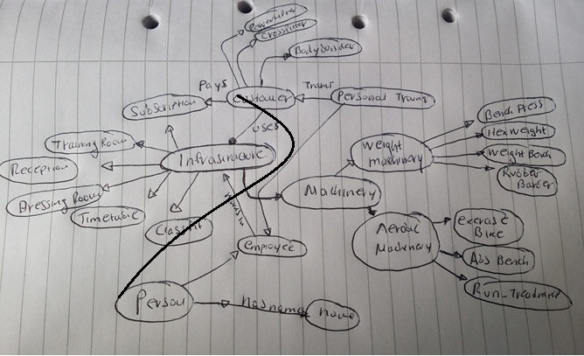

*SPARQL queries*

*1.*

*Prefix b: <http://www.semanticweb.org/ssatm/ontologies/2017/3/untitled-ontology-7>*

*Select ?resource ?property ?object*

*Where {?resource ?property ?object}*

*2.*

*Prefix b: <http://www.semanticweb.org/ssatm/ontologies/2017/3/untitled-ontology-7>*

*Select ?resource ?Pays ?object*

*Where {?resource ?Pays ?object}*

*3.*

*Prefix b: <http://www.semanticweb.org/ssatm/ontologies/2017/3/untitled-ontology-7>*

*Select ?resource ?IsPayedBy ?object*

*Where {?resource ? IsPayedBy ?object}*

*4. Prefix b: <http://www.semanticweb.org/ssatm/ontologies/2017/3/untitled-ontology-7>*

*Construct ?resource ?IsPayedBy ?object*

*Where {?resource ? IsPayedBy ?object}*

*5.*

*Prefix b: <http://www.semanticweb.org/ssatm/ontologies/2017/3/untitled-ontology-7>*

*Construct ?resource ?IsPayedBy ?object*

*Where {?resource ? IsPayedBy ?object*

*FILTER ?resource>5}*

*Critique*

The ontology for the University of Strathclyde’s Centre for Sport & Recreation, constitutes from 3 main classes. Infrastructure class, Machinery class, and Person class. The infrastructure class represents basic concepts like the “places” that are used by sport center’s athletes, such as training room, dressing room, and more general concepts like time table of a class, and a subscription. The machinery class contains the specific equipment that is included in a specific class, or which is used by specific kind of customers (Bodybuilder, Cross fitter), depending the type of exercises they want to do. The person class represents the people that are related with the sport center domain, like customers, employees, and type of athlete’s subclasses. The three classes have some common modifiers like for example, a person and more specifically a customer subclass, has a name attribute (modifier), has specific gender, and weight. Additionally the machinery class has some common modifiers, for example a Rubber Barbell has a weight modifier. The Infrastructure classes subclasses, are related also with modifiers like name, cost of a subscription, or a gender that characterizes a specific dressing room. The modifier gender modifies also the class person, and its subclasses. Some definable have also identified by the diagram like a Personal trainer who is an Employee (person subclass)and trains only customers with Gold subscription or an Aerobics class which is a infrastructure subclass that uses some Aerobic machinery (machinery subclass). Using relations we can define triples for the ontology like: an Abs class has an Abs Bench, and characterizing them according to their type. The property domain and range are also included in this document which links individuals from the domain to individuals from the range( For example a person hasname name) which is a functional property. A restriction to “Aerobics class = class that uses some Aerobic machinery” is an existential restriction describes a class of individuals that have at least one (some) relationship along a specified property to an individual that is a member of a specfied class. In order for something to be an aerobic it is necessary for it to have at least one aerobic machine.

The decision to create three classes was based on the three basic concepts of a sports center. The human beings, the infrastructure and the machinery, which also could be a subclass of infrastructure but was decided to create separate classes as the number of subclasses would be huge for the infrastructure class, and also the machinery class is specify the equipment and not general concepts like subscription. The ontology matches the problem domain, characterizing basic concepts functions and relations between the different “objects” of a sports center domain. Relations between the objects and the use of OWL/XML can answer questions about the sports center domain. The specific implementation and the decision to use three classes were chosen after collecting and analyzing the self-standing entities, the modifiers and organizing into trees. Then creating triples using “subject-predicate-object” defining the relations and creating definable using axioms derived from other concepts the design of the specific ontology was decided. This was an iterative process and many changes were made using the protégé tool. An alternative approach for designing this ontology would be to use two classes instead of three. The machinery class could be a subclass of infrastructure, including the subclasses Aerobic machinery and Weight machinery.